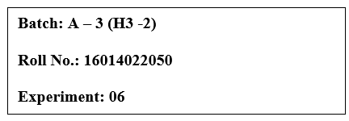

**Title: Working with Geospatial data**

# Objective:

1. *Search/locate and download the geospatial Data (Use same dataset if it contains location information)*
2. *To learn how to visualize geospatial data*
   1. *Auto Geo-tagging*
   2. *Custom Geo-tagging*
3. *Apply heat map*
4. *Try various forms of heat maps*
5. *Analyze the visualization and write your interpretation after observation on heat-map*
6. [*Interactive*](https://www.youtube.com/watch?v=_h_WjKhApFc&ab_channel=HarpreetBedi) *filtering over map*
7. *Following maps should be demonstrated*
   1. *Proportional symbol maps*
   2. *Choropleth maps (filled maps)*
   3. *Point distribution maps*
   4. *Density maps (heatmaps)*
   5. *Flow maps (path maps)*
   6. *Spider maps (origin-destination maps)*

# Course Outcome:

# CO1: Learn how to locate and download datasets, extract insights from that data and present their findings in a variety of different formats.

# CO3: Apply data visualization best practices.

# Books/ Journals/ Websites referred:

# None.

# Resources used:

[hftps://www.ecdc.europa.eu/en/publications-data/download-todays-data-geographic](https://www.ecdc.europa.eu/en/publications-data/download-todays-data-geographic-distribution-covid-19-cases-worldwide)

[-distribution-covid-19-cases-worldwide](https://www.ecdc.europa.eu/en/publications-data/download-todays-data-geographic-distribution-covid-19-cases-worldwide)

# Theory:

* **Definition:**

In mathematics, a time series is a series of data points indexed in time order. Most commonly, a time series is a sequence taken at successive equally spaced points in time. Thus, it is a sequence of discrete-time data that represents the evolution of a particular phenomenon or variable over a speciﬁed period. Time series data is often used in various ﬁelds, including economics, ﬁnance, physics, engineering, and many others, to analyze and model temporal patterns, trends, and relationships. These data points can be collected at regular intervals, such as daily, monthly, or yearly, and are essential for studying and predicting changes or behaviors over time. Time series analysis involves various techniques, such as statistical modeling, forecasting, and data visualization, to gain insights and make informed decisions based on historical and future trends in the data.

# Following points should be written by students:

## Observation after plotting data

1. Observation after plotting various forms of maps like based on visualization Que

## Interpretation of visualized map

**Note:** Detail observation needed along screenshots wherever required

I'm switching databases as the original one lacked comprehensive geographic information. The new database provides a better foundation for this assignment’s geographical analysis.

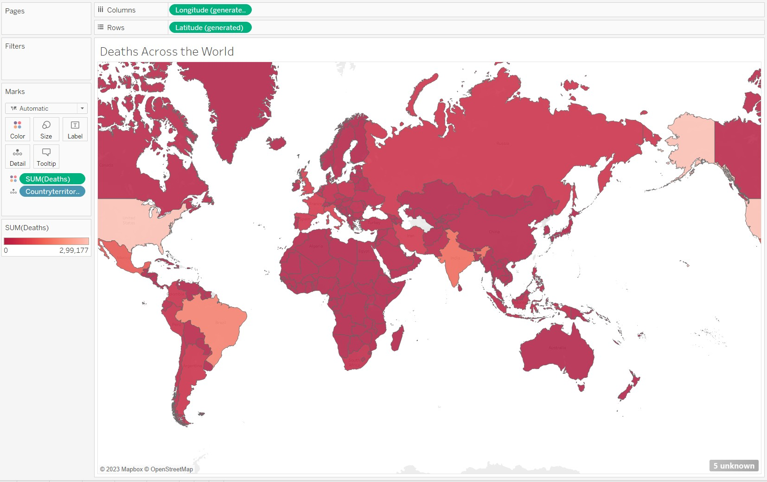

This map illustrates the regional distribution of COVID-19 fatalities, with varying shades of a single color. The deeper hues represent a higher concentration of deaths within speciﬁc areas. Notably, the United States has the most signiﬁcant concentration of fatalities, with Brazil, India, Italy, Russia, and other countries following in descending order.

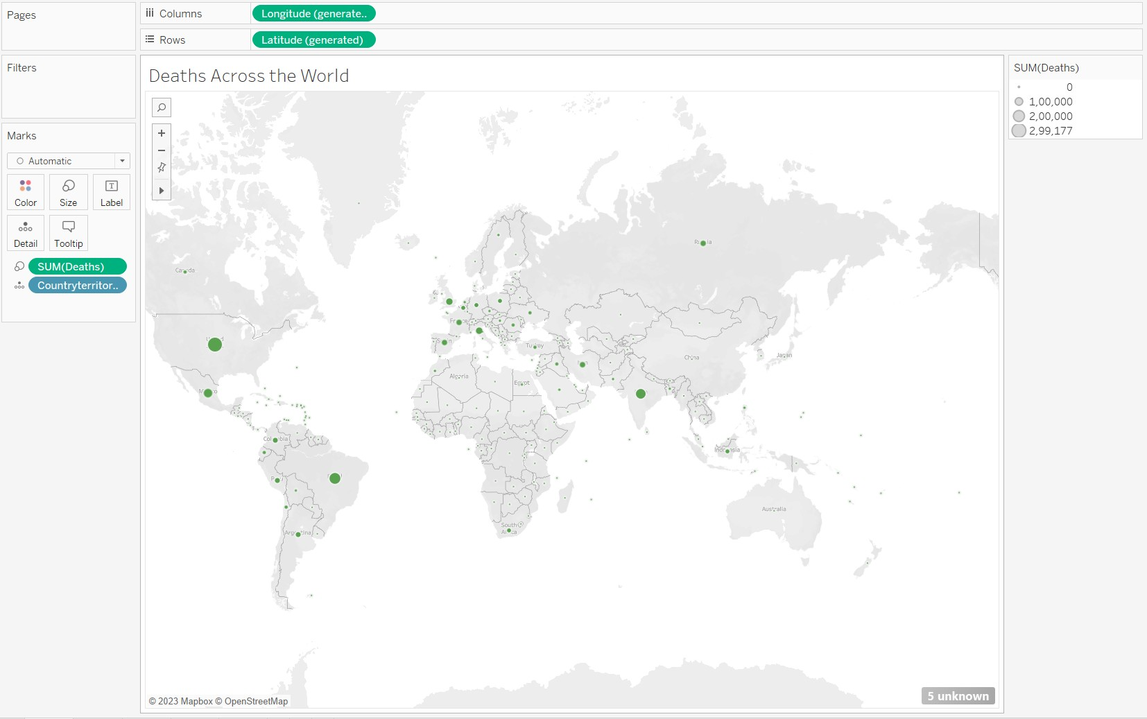

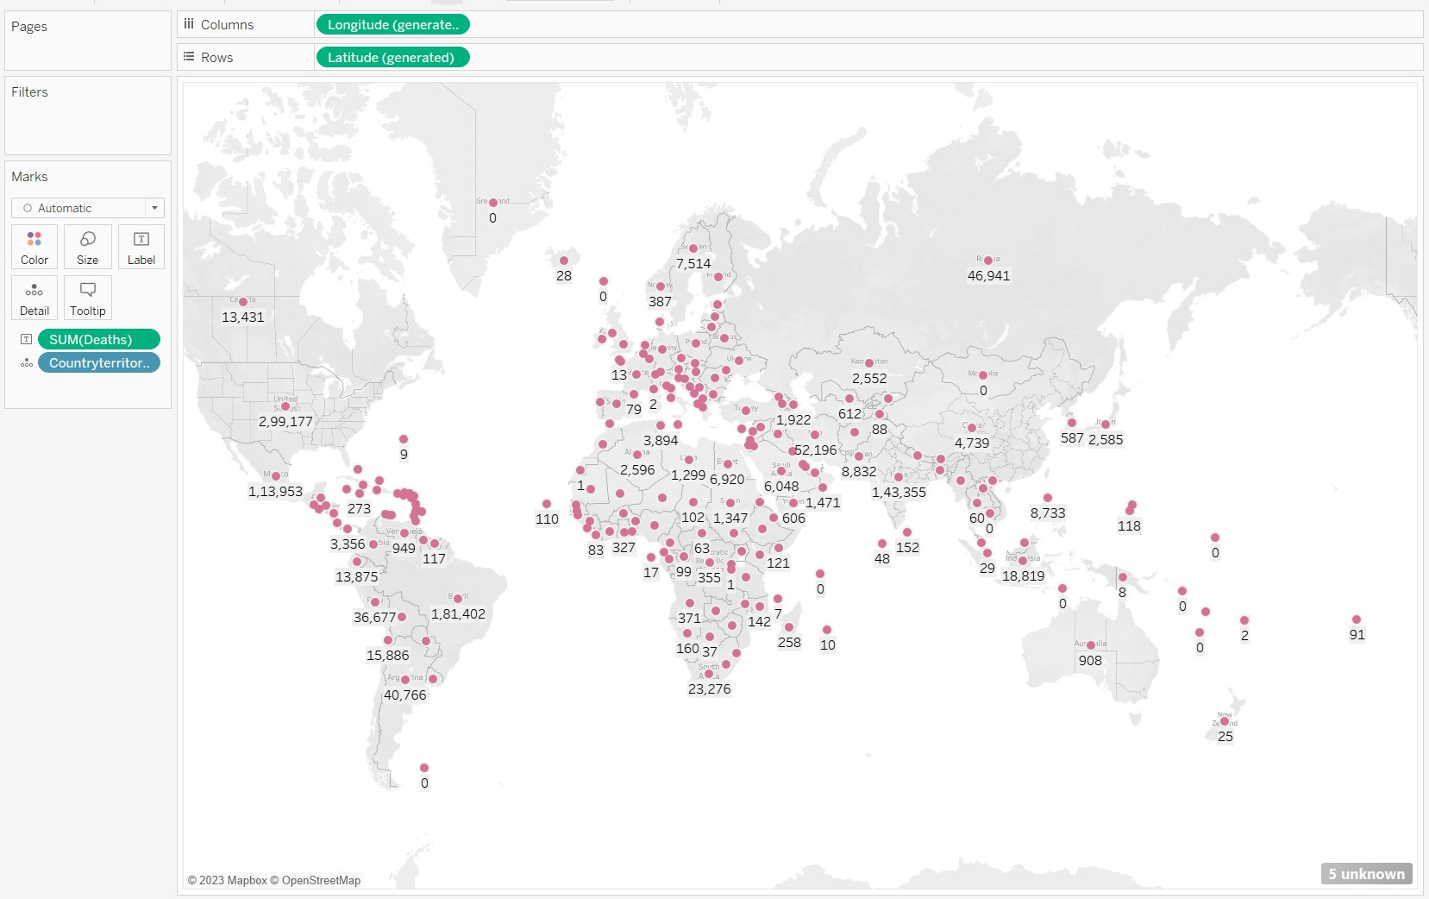This map uses varying circle sizes to depict data, with larger circles denoting higher numbers of deaths. The accompanying scale on the right clariﬁes the correlation between circle size and the number of fatalities.

This map uses varying circle sizes to depict data, with larger circles with actual values of numbers of deaths.

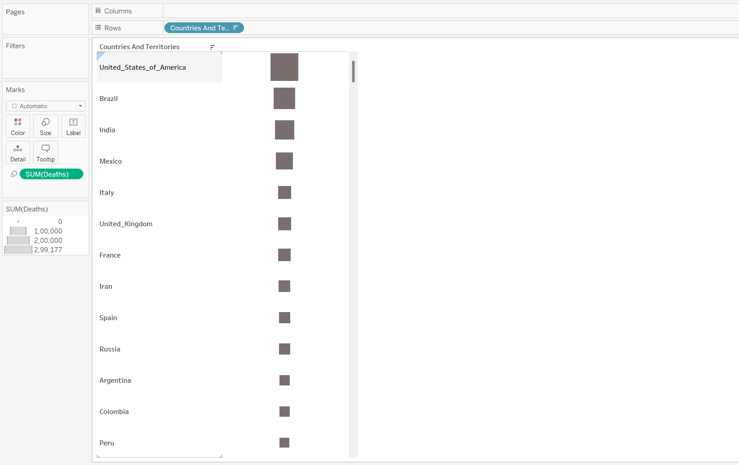

Here's a heat map illustrating COVID-19 fatalities. The varied box sizes represent the density of deaths within speciﬁc regions.

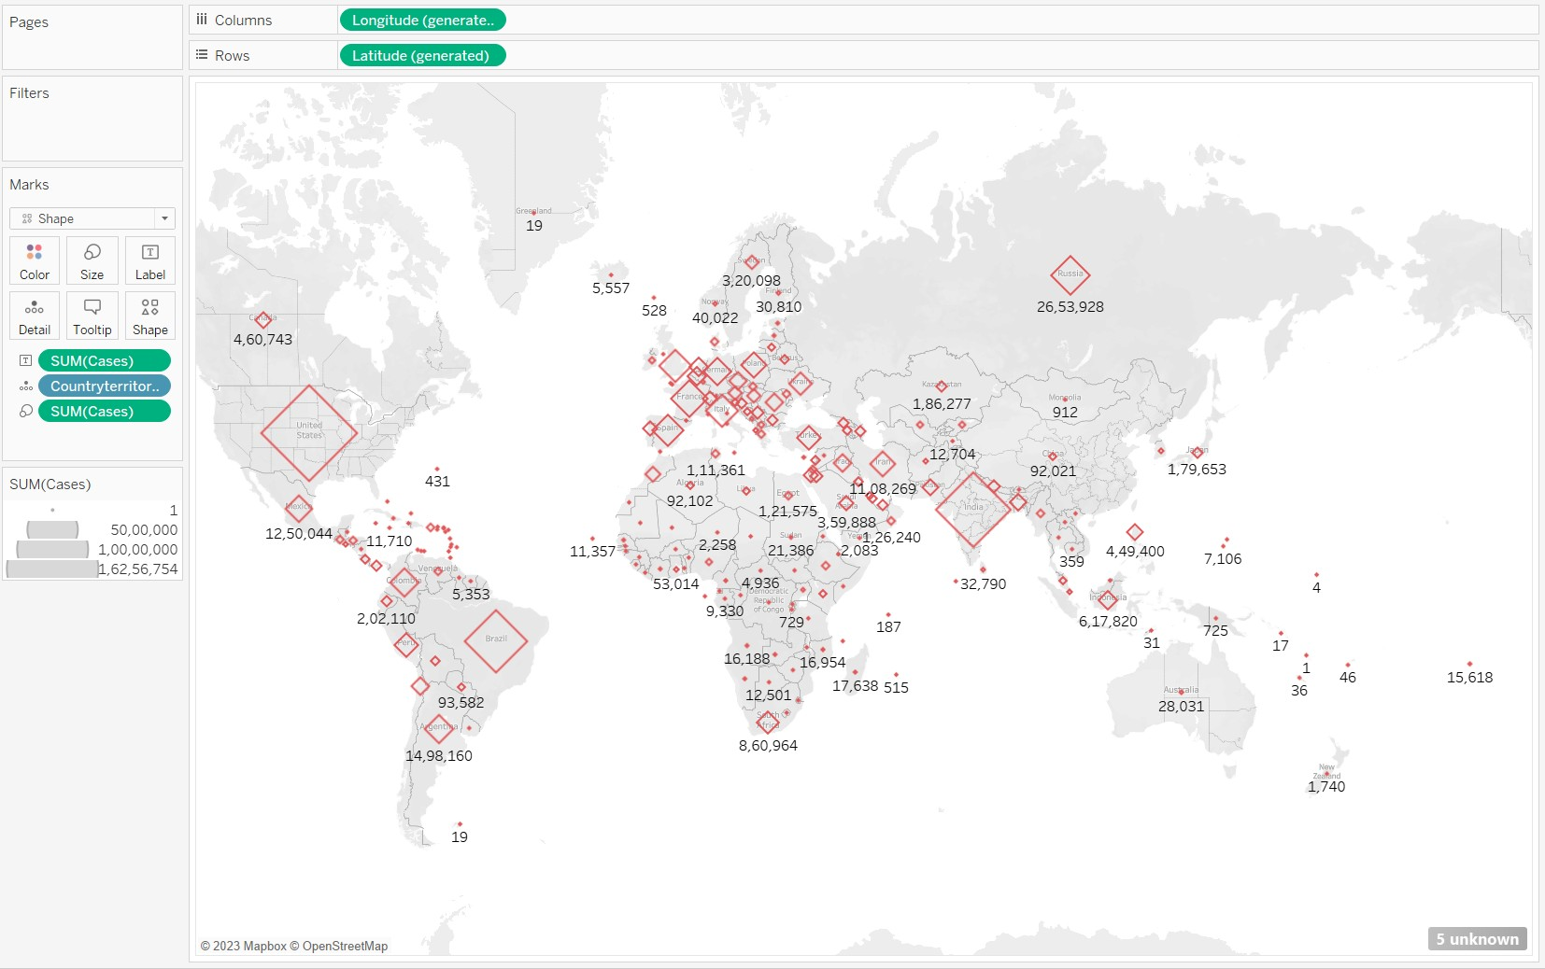

Proportional Symbol Map:

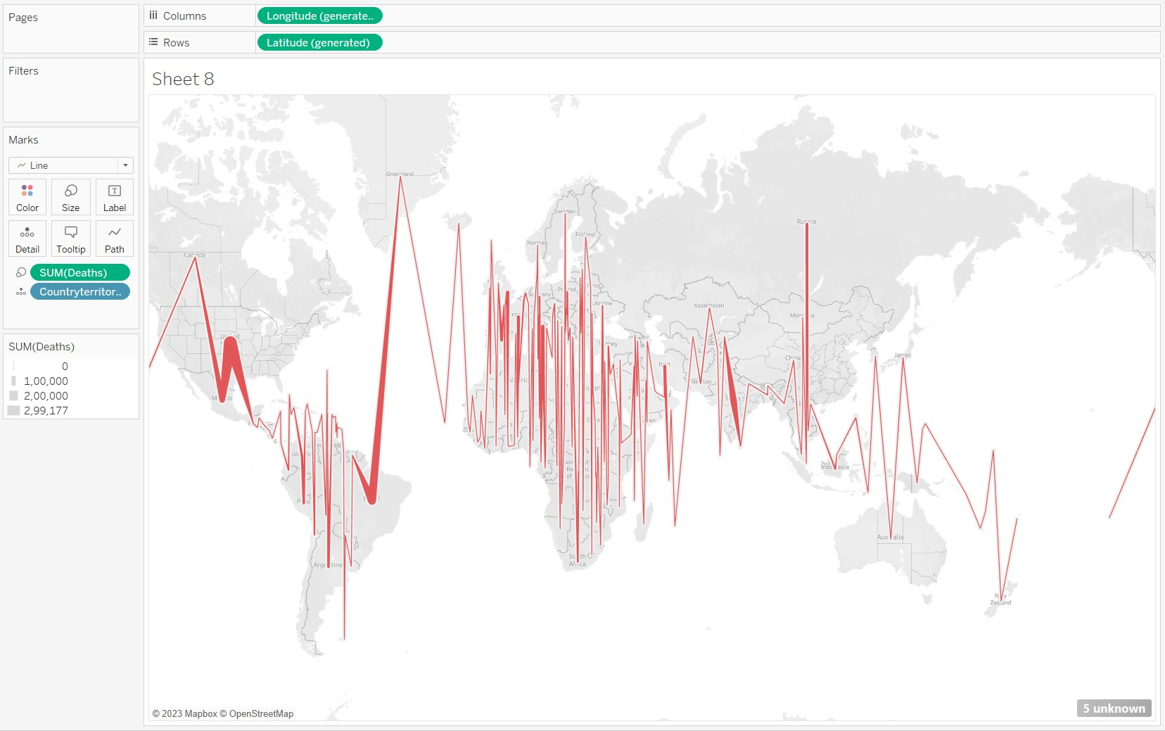

# Conclusion (Students should write in their own words, comparative conclusion needed):

Throughout this experiment, we acquired the skill of generating heat maps using Tableau software. These heat maps enabled us to examine diﬀerent sectors by interpreting the color distribution, ultimately allowing us to present the dataset in a more comprehensible and visually impactful way.

# Date: 10 / 10 / 2023 Signature of faculty in-charge

# Post Lab Question:

**1. Explain the Choropleth maps.**

* Choropleth Maps display divided geographical areas or regions that are colored, shaded or patterned in relation to a data variable. This provides a way to visualize values over a geographical area, which can show variation or patterns across the displayed location.
* The data variable uses color progression to represent itself in each region of the map. Typically, this can be a blending from one color to another, a single hue progression, transparent to opaque, light to dark or an entire color spectrum.
* One downside to the use of color is that you can’t accurately read or compare values from the map. Another issue is that larger regions appear more emphasized than smaller ones, so the viewer’s perception of the shaded values are aﬀected.
* A common error when producing Choropleth Maps is to encode raw data values (such as population) rather than using normalized values (calculating population per square kilometer for example) to produce a density map.